QUESTION 6:

E-TICKETING SYSTEM:

COMPONENT DIAGRAM:

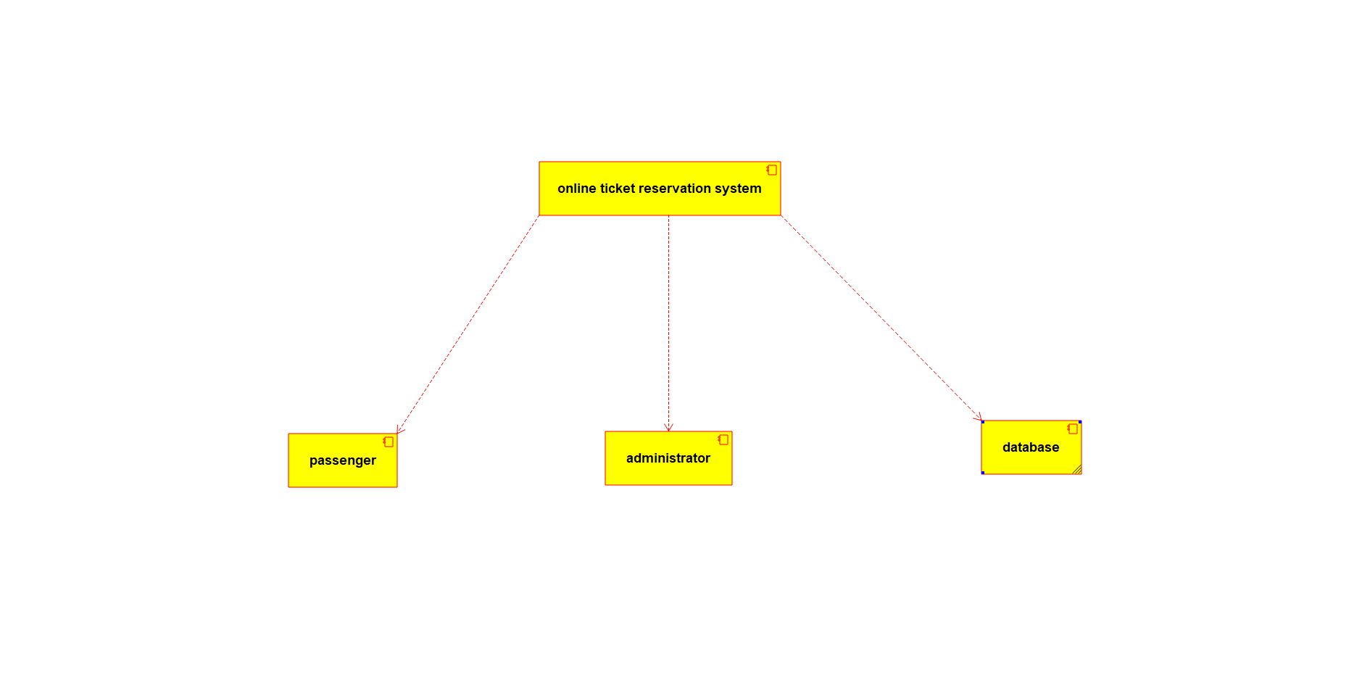

DEPLOYMENT DIAGRAM:

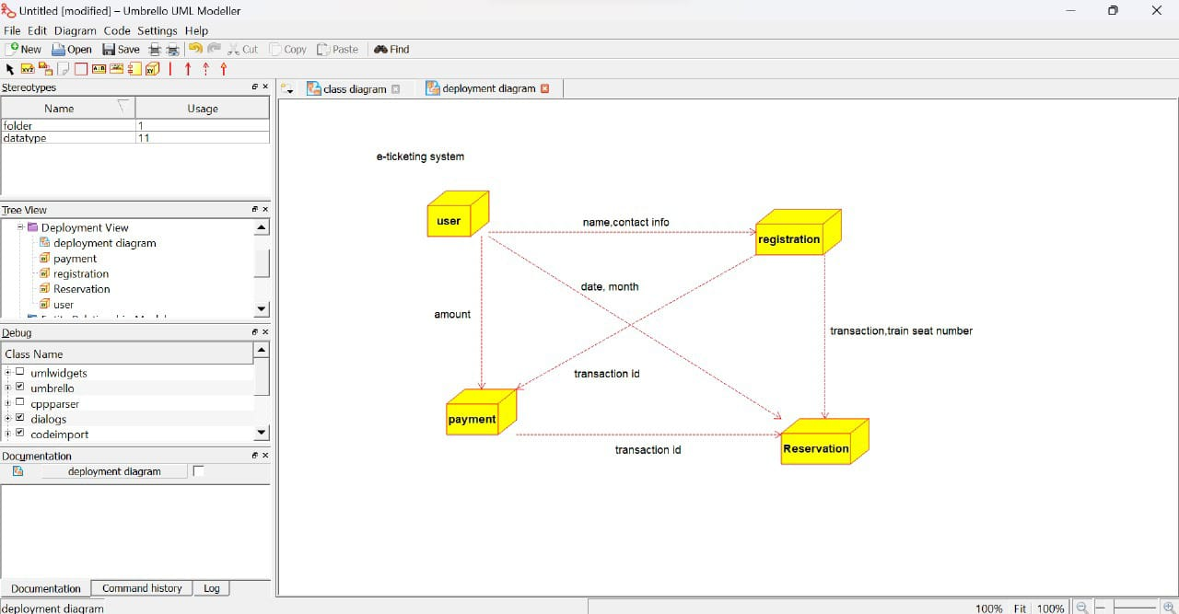

ACTIVITY DIAGRAM:

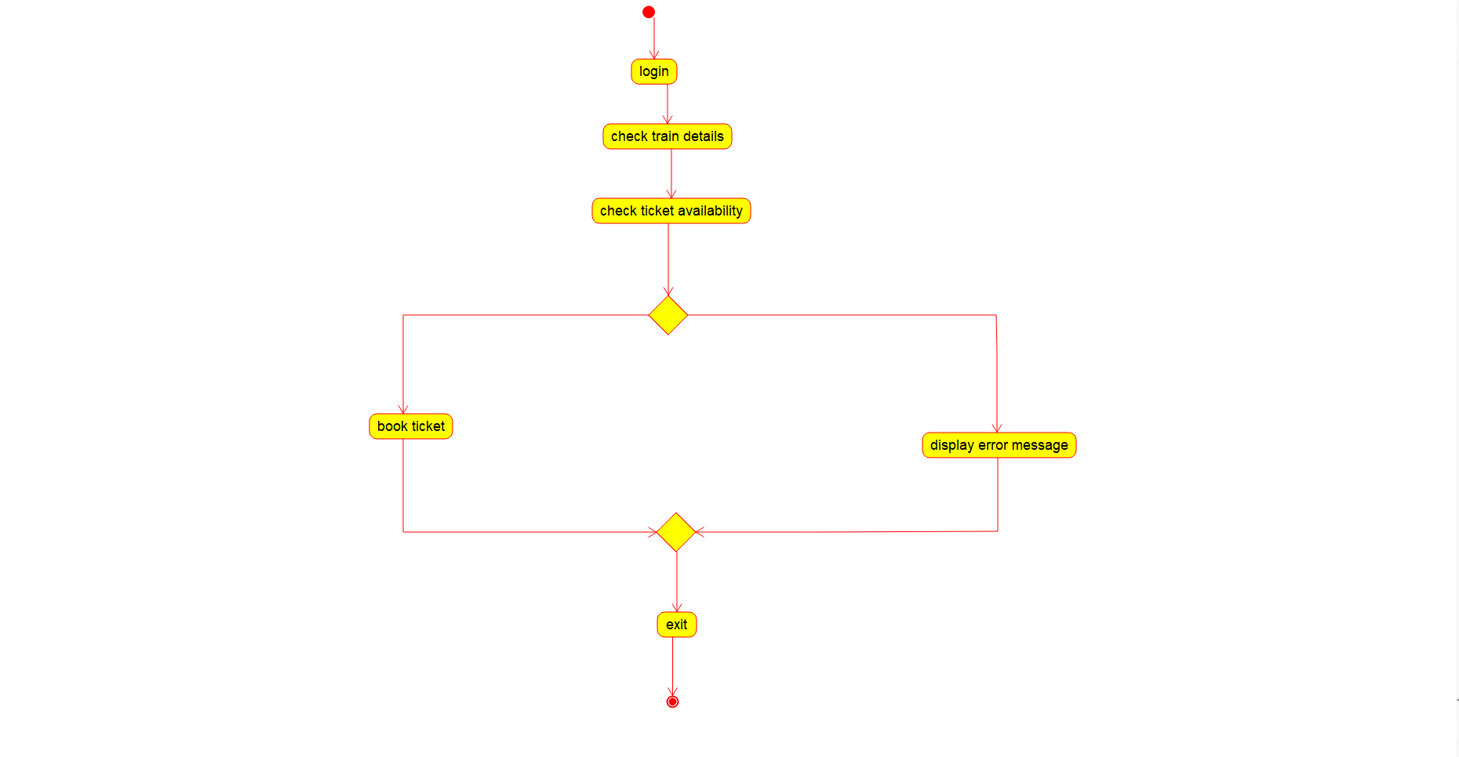

USE CASE DIAGRAM:

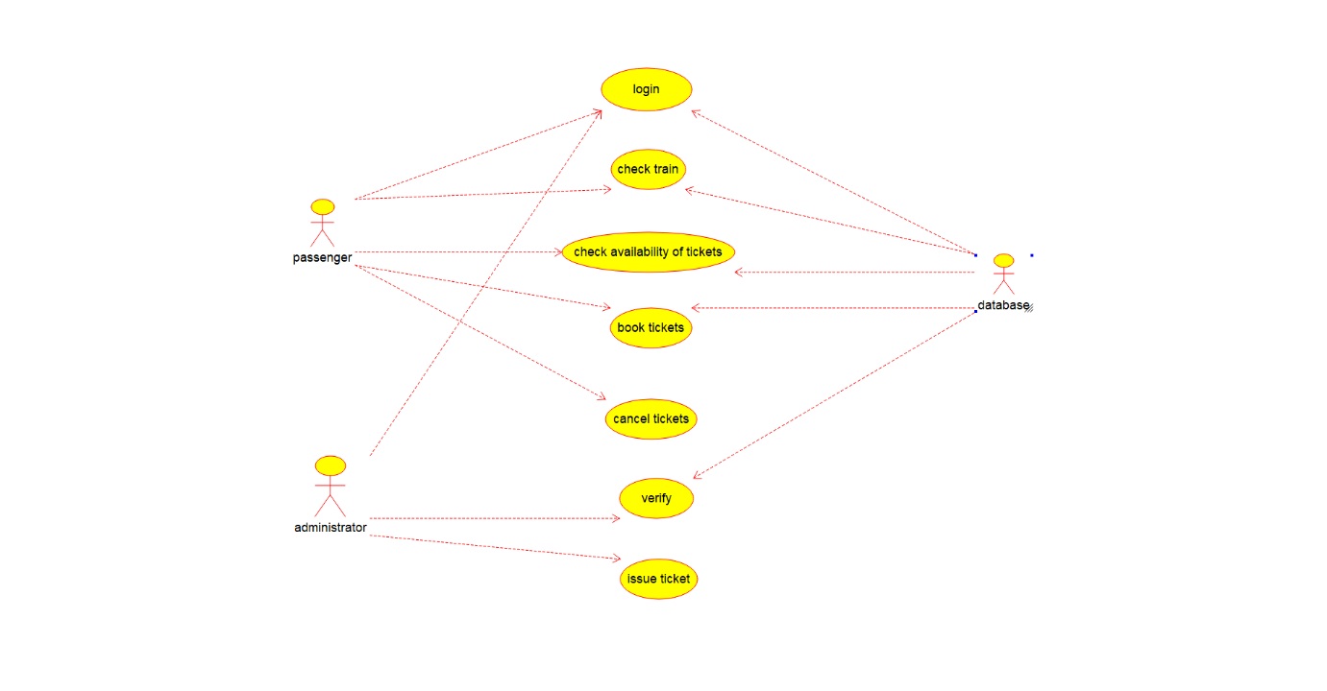

CLASS DIAGRAM:

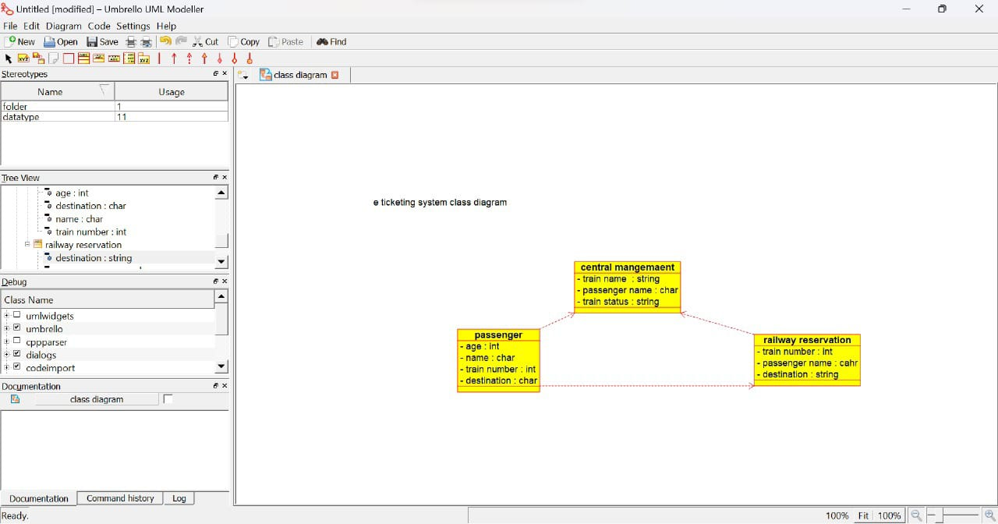

SEQUENCE DIAGRAM:

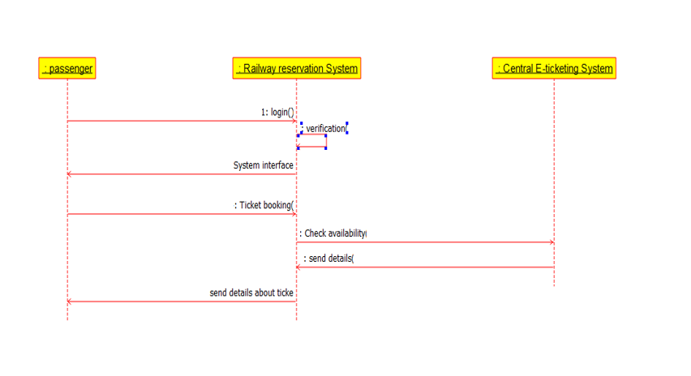

STATE DIAGRAM:

